MAC architecture fundamentals
The MAC (Media Access Control) sublayer sits at the bottom of the data link layer and orchestrates everything between the software stack above and the physical medium below.
Its architecture can be understood as four interlocking systems:
- Service interfaces that define what the MAC offers to upper layers,
Internal Sublayer Service (ISS)
Enhanced Internal Sublayer Service (EISS)
- DMA engine that moves frame data between the MAC and system memory without burdening the CPU
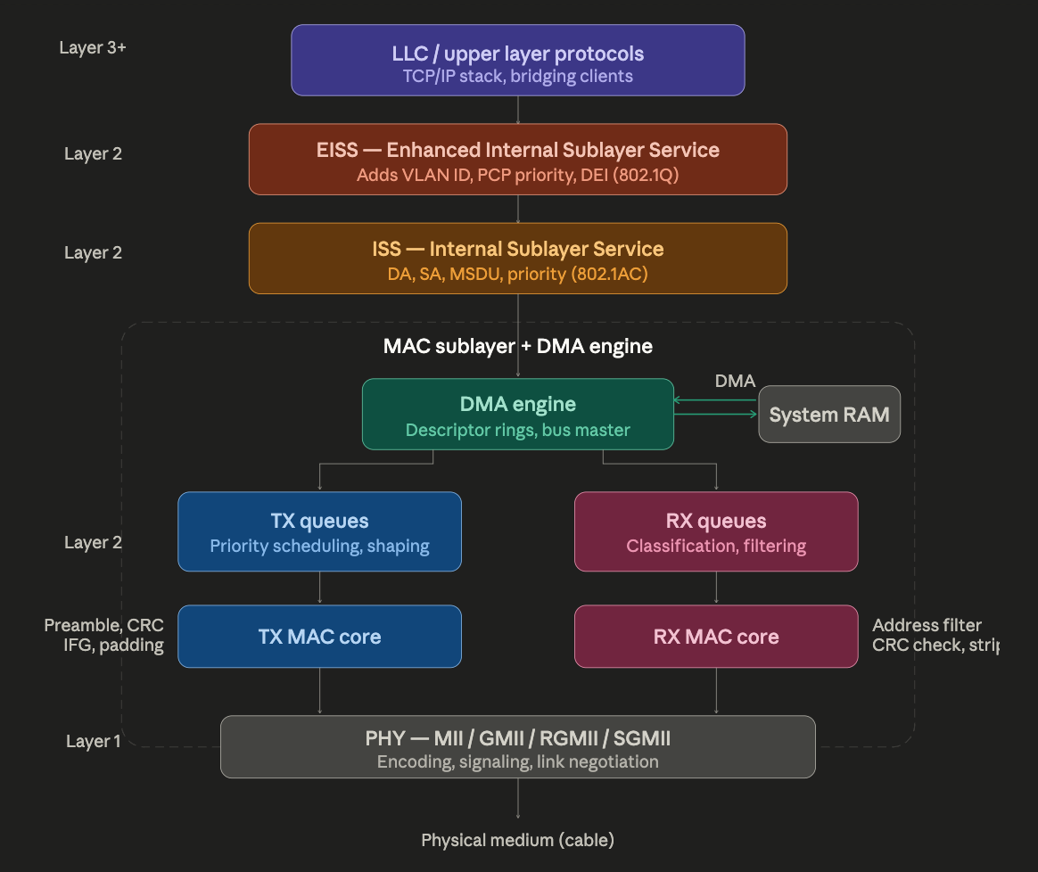
- TX/RX queues that buffer and schedule frames in both directions.

ISS — Internal Sublayer Service (IEEE 802.1AC)
The ISS is the foundational abstraction that makes all IEEE 802 MACs look identical to higher layers, regardless of whether the underlying medium is Ethernet, Wi-Fi, or anything else. It defines a set of service primitives — essentially function calls with specific parameters — that any MAC must support. The key primitives are M_UNITDATA.request (transmit a frame) and M_UNITDATA.indication (a frame has arrived), both carrying: destination address (DA), source address (SA), the MAC Service Data Unit (MSDU, i.e. the payload), and a priority value.
The ISS is what MAC Bridges (switches) operate on internally — the relay entity inside a bridge receives frames via ISS indications on one port and issues ISS requests on another.

EISS — Enhanced Internal Sublayer Service (IEEE 802.1Q)
The EISS extends the ISS with VLAN-awareness. It adds three parameters to every primitive: the VLAN Identifier (VID, 12 bits, up to 4094 VLANs), the Priority Code Point (PCP, 3 bits, 8 priority levels), and the Drop Eligible Indicator (DEI). These are the fields that get encoded into the 802.1Q VLAN tag in the frame.
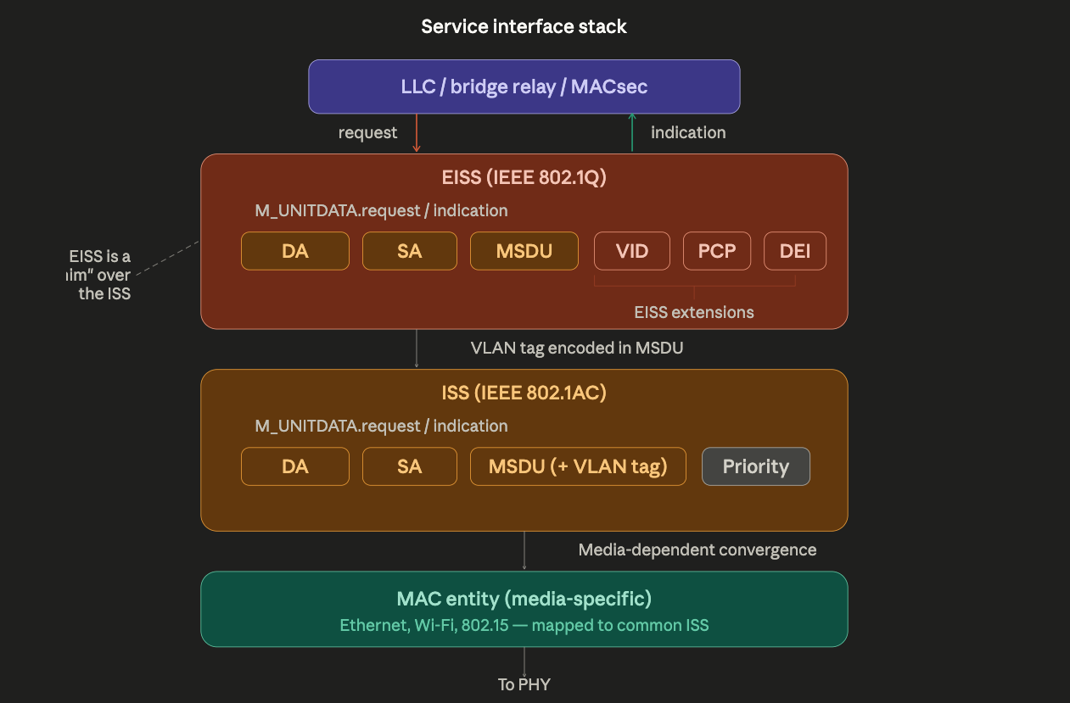

The critical insight here is how the EISS relates to the ISS. The EISS is what 802.1Q calls a "shim" — it provides the same type of service it consumes, but enriched with VLAN parameters. When an EISS request is made, the VLAN tag (containing VID, PCP, DEI) is encoded into the MSDU itself, and then forwarded as a standard ISS request. The receiving side does the reverse — the ISS delivers the frame, the EISS shim strips the VLAN tag from the MSDU and presents the VID/PCP/DEI as separate parameters in its indication primitive. This design means all existing ISS-based protocols (bridging, MACsec, link aggregation) work unchanged — they simply see a slightly longer MSDU.

DMA engine — descriptor rings and zero-copy transfers
The DMA engine is the hardware mechanism that decouples frame processing from CPU intervention. Instead of the CPU manually copying every byte between the MAC and system memory, the DMA controller operates as an independent bus master that reads and writes memory directly.
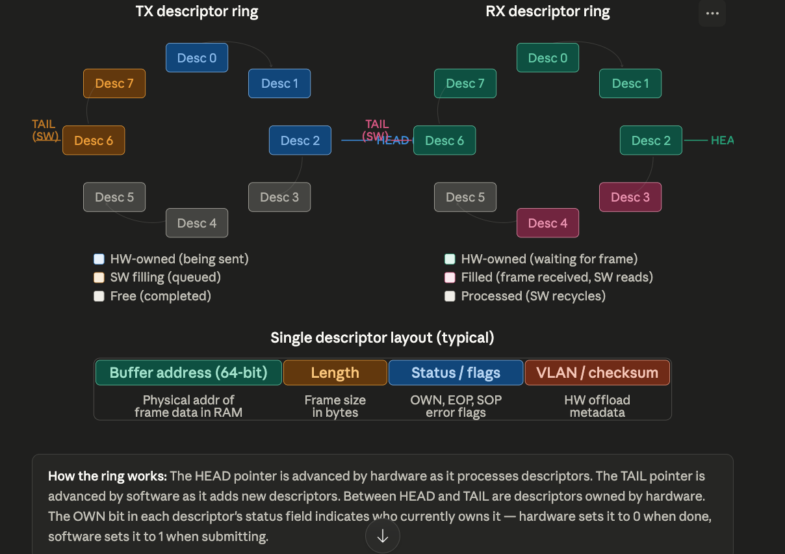
The core data structure is the descriptor ring — a circular buffer in system memory containing descriptors that point to frame data buffers. There is one ring for TX and one (or more) for RX.

The ownership protocol between hardware and software is the core mechanism. For the TX path: the driver writes frame data to a buffer in system memory, fills a descriptor with the buffer's physical address and length, sets the OWN bit, and advances the TAIL pointer. The DMA engine sees the new descriptor, reads the frame data via bus-mastering DMA, transmits it through the TX MAC, clears the OWN bit, and advances HEAD. The driver later reclaims the descriptor.
For the RX path it works in reverse: the driver pre-allocates empty buffers and sets up descriptors pointing to them (OWN = 1, meaning "hardware may write here"). When a frame arrives, the DMA engine writes the received data into the next available buffer, fills in the length and status fields, clears OWN, and raises an interrupt. The driver reads the frame, processes it, then recycles the descriptor with a fresh buffer.

TX/RX queues — priority scheduling and traffic classification
Modern MACs support multiple queues in each direction. This is essential for QoS, traffic shaping (802.1Qav/Qbv for TSN), and for distributing load across CPU cores.
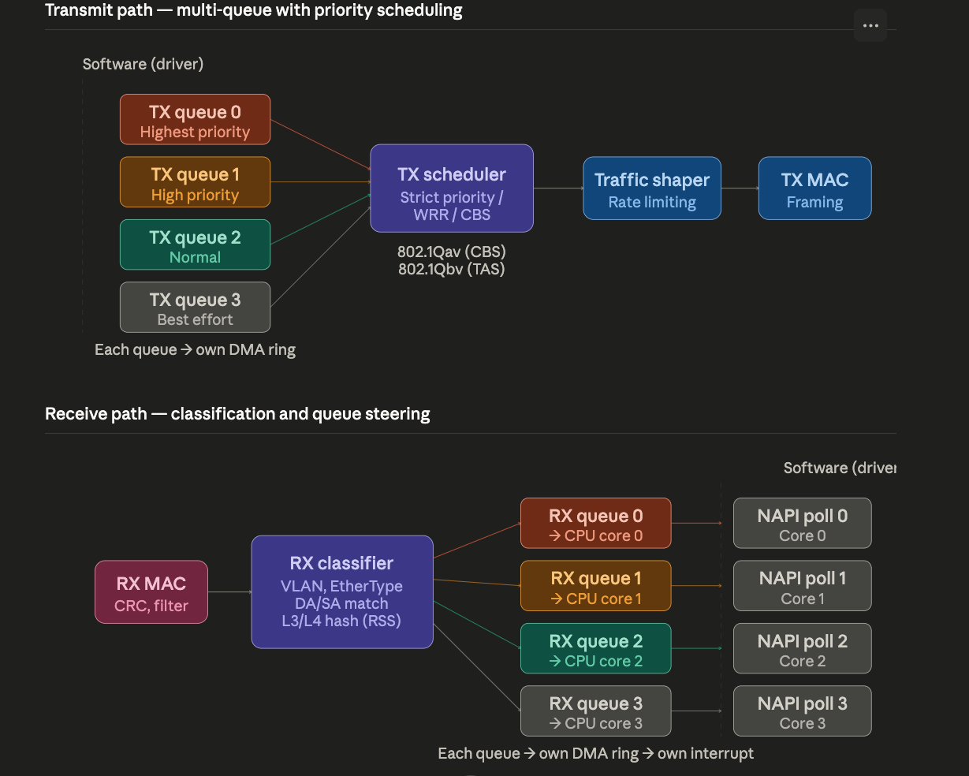
The TX side uses a scheduler that arbitrates between queues according to one of several policies: strict priority (highest-numbered queue always wins), weighted round-robin (WRR, each queue gets a proportional share), or credit-based shaping (CBS, per 802.1Qav for audio/video bridging). In TSN (Time-Sensitive Networking) deployments, the scheduler can also implement time-aware shaping (802.1Qbv) with gate control lists that open and close queue gates on a precise schedule. After scheduling, a traffic shaper enforces rate limits before the frame reaches the TX MAC core, which prepends the preamble, appends the CRC, enforces minimum frame size (padding), and manages the inter-frame gap (IFG).
The RX side operates differently. After the RX MAC validates the CRC and runs address filtering (unicast match, multicast hash, promiscuous mode), the frame enters the RX classifier. This hardware parser inspects VLAN tags, EtherType, and optionally L3/L4 headers to compute a hash (Receive Side Scaling / RSS) that steers the frame to a specific RX queue. Each queue has its own DMA descriptor ring and its own interrupt vector, which means each queue can be serviced by a different CPU core — this is how modern NICs achieve multi-gigabit RX throughput by parallelising packet processing across cores. In Linux, each queue maps to a NAPI polling context bound to a specific core.

Putting it all together — frame lifecycle
Here is the complete journey of a single frame through the architecture, from application write to wire transmission.
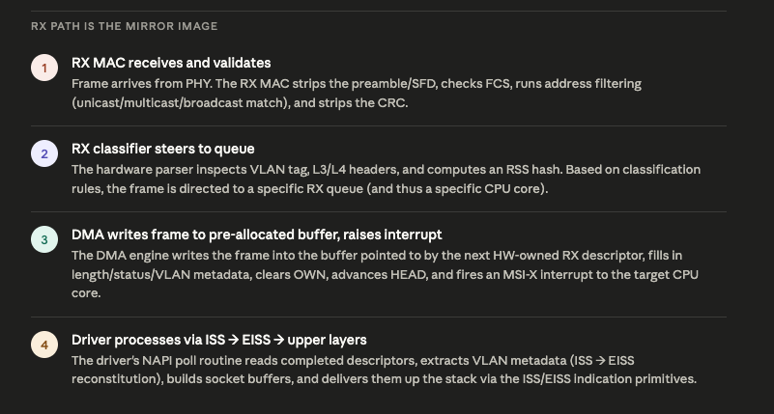
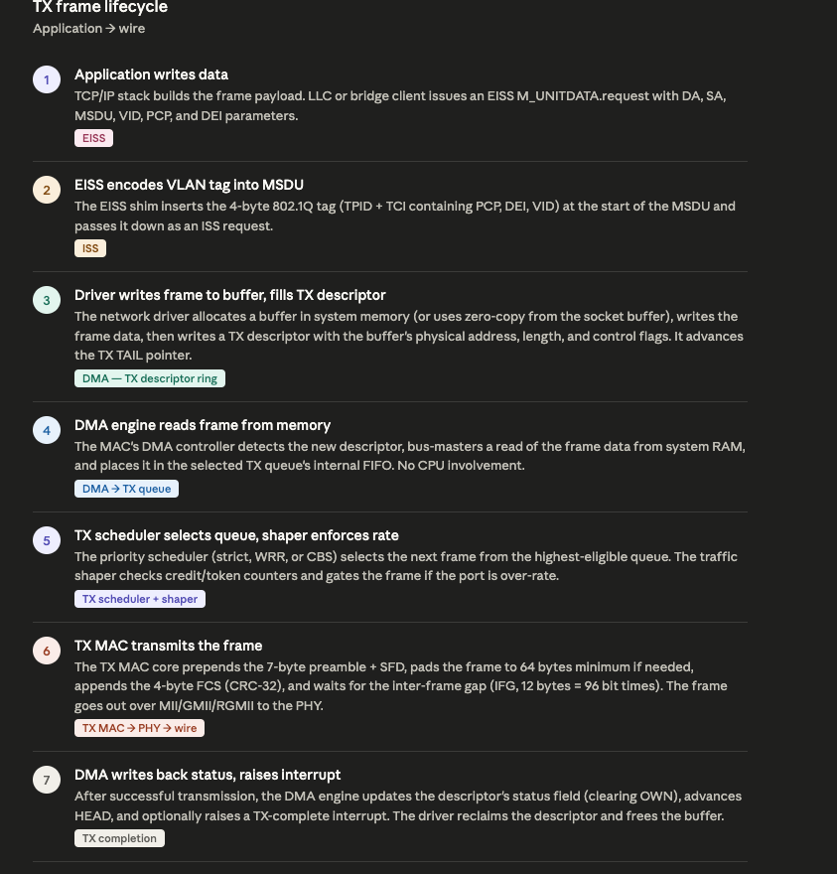

Summary of relationships
The four subsystems interlock in a precise hierarchy. The ISS defines the media-independent contract — what the MAC promises to deliver regardless of whether it's Ethernet, Wi-Fi, or something else. The EISS sits as a shim on top of the ISS, adding VLAN awareness by encoding/decoding the 802.1Q tag within the ISS MSDU — this is what makes VLAN-aware bridging, QoS classification, and MACsec all composable without rewriting each protocol for every new feature.
The DMA engine is the physical mechanism that fulfils the ISS contract — it moves frame data between system memory and the MAC hardware via descriptor rings, using bus-mastering to avoid CPU bottlenecks. The TX/RX queues sit between the DMA and the MAC cores, providing the multi-priority and multi-core capabilities that modern networking demands: TX queues feed through a scheduler (strict priority, WRR, or credit-based shaping for TSN), while RX queues are filled by a hardware classifier that steers frames based on VLAN, protocol headers, or RSS hashes.
The entire design philosophy is one of layered abstraction and hardware offload — each layer does one thing cleanly, and the DMA engine ensures the CPU is only involved in policy decisions (which queue, what priority, which core), never in the mechanical act of copying bytes.

